**Rise of Delivery**

This appendix analyze the data for the increase in delivery / takeout popularity that we implemented in Phase 1.

<https://www.avalara.com/us/en/blog/2020/05/what-our-data-has-to-say-about-covid-19s-impact-on-consumer-spending.html>

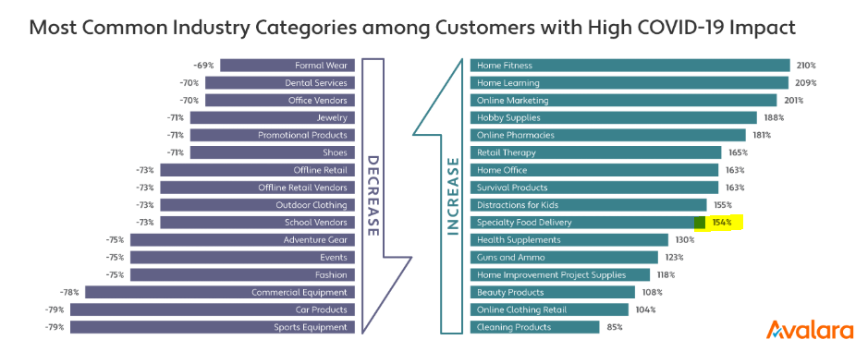

As shown, many industries have seen of a 100% increase in delivery services. Food delivery, as highlighted above, has seen an increase of 154%.

<https://upserve.com/restaurant-insider/mapping-restaurant-recovery-from-coronavirus-via-online-ordering-data/>

This graph agrees with the previous graph, indicating that online delivery drastically increase due to COVID-19.

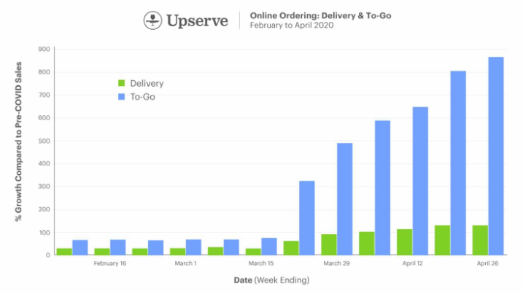

As shown above, To-Go and Delivery food drastically increase.

<https://www.restaurantbusinessonline.com/technology/how-coronavirus-reshaping-ordering-payment>

The below graph shows how customers’ behavior changed during COVID-19. Ordering in-person drastically decrease while online ordering increase.

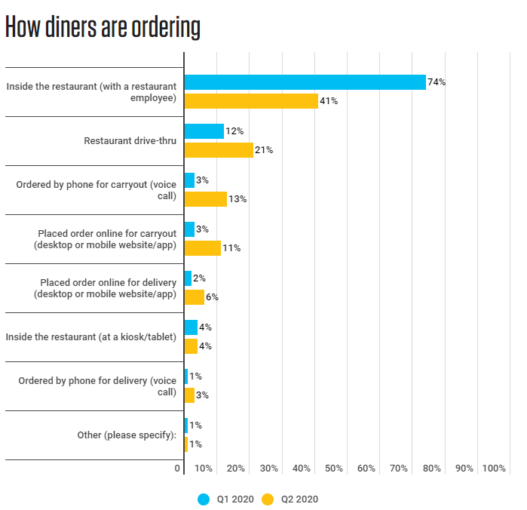

All three sources of data suggest that moving our operations to delivery/take-out will bring profit due to increase demand for online ordering and delivery.

<https://philly.eater.com/2020/3/20/21186948/philadelphia-restaurants-open-delivery-takeout-pickup-coronavirus>

<https://philadelphia.cbslocal.com/coronavirus-latest-restaurants-offering-delivery-take-out-deals-in-philadelphia-area-during-shutdown/>

Attached above is two links to look at how other restaurants are handling the coronavirus pandemic. As shown, a majority of restaurant choose to move their operations online either through first-party delivery drivers or third-party services such as UberEats, Caviar, and Postmates.

<https://www.spoton.com/blog/using-online-ordering-to-adapt-your-restaurant-to-covid-19-restrictions>

Attached in the above link is a page for a company called SpotOn. SpotOn makes POS handheld devices for restaurants. According to this blog, first party delivery is the best way to make a profit.